**Project: Human Resources Dataset Analysis**

**Date: 1/10/2024  
Prepared by: Team 2 (Hisham, Ahmed Sabry, Karim & Israa)**

1. **Introduction**

* **Purpose**: Explain the HR analysis and its role in improving decision-making for employee management, performance tracking, and workforce planning.
* **Dataset Overview**:
  + Five tables: Employee, Performance Rating, Education Level, Rating Level, and Satisfaction Level.

1. **Data Cleaning and Preprocessing**

* **Data Relationship Setup**:
  1. the tables are related through primary keys.
* EmployeeID connects the Employee & Performance Rating tables.
* SatisfactionID, RelationshipSatisfaction , EnvironmentSatisfaction & JobSatisfaction connects Performance Rating & Satisfied Level tables
* RatingID , SelfRating, & ManagerRating connects Performance Rating & Rating Level tables
* EducationLevelID connects the Employee & Education Level tables

* **Data Formatting**:
  1. Date fields (HireDate and ReviewDate) standardized to DD/MM/YYYY.
  2. Renaming columns (e.g., changing Education to EducationLevelID).
  3. Mapping values (e.g., changing Stock option Level codes 0-3 to meaningful labels: "None," "Low," "Medium," and "High").
  4. State abbreviations mapped to full names (e.g., IL to Illinois, CA to California).
  5. Replacing one word of “Marketing” instead of 2 instances.
* **DAX Calculations**:

1. **Years at Company**: DAX function calculates the number of years an employee has been at the company.
2. VAR LatestReviewDate: It calculates the latest review date for an employee based on their EmployeeID. It uses CALCULATE with MAX to get the most recent review date from the PerformanceRating table, ignoring all filters except the employee.
3. RETURN:

* If the latest review date is before the employee’s hire date or before January 1, 2022, the function returns the value from the YearsAtCompany column for that employee.
* A screenshot of a computer code

  Description automatically generatedOtherwise, it calculates the difference in years between the employee’s hire date and the latest review date, using DATEDIFF.

1. **Attrition Rate**: DAX calculation for the proportion of employees who have left.



1. **Retention Rate**: DAX calculation for the proportion of employees still with the company.



1. **JobSatisfactionMeasure**: DAX calculation for the count of performance ratings based on a specific relationship between satisfaction levels and job satisfaction within the dataset.

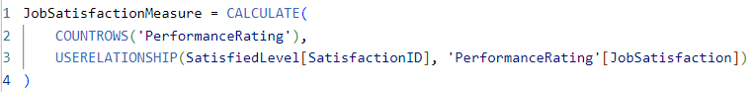

1. **RelationshipSatisfactionMeasure:** DAX calculation for the count of performance ratings based on a specific relationship between satisfaction levels and relationship satisfaction within the dataset.

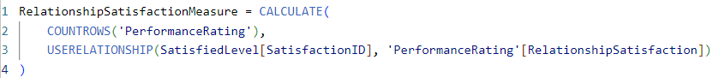

1. **SelfRatingMeasure:** DAX calculation for the count of performance ratings based on a specific relationship between rating levels and self-rating within the dataset.

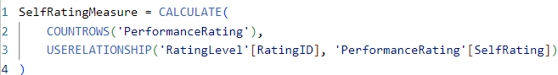

1. **WorkLifeBalanceLabel:** DAX formula to translate the numeric work-life balance ratings into descriptive text labels.

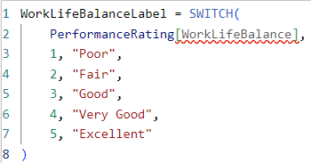

1. **Data Analysis Questions**

**1. Employee Attrition Analysis**

**Scope**: Understand the factors that contribute to employee turnover.

* **Questions**:
  + What are the key drivers of employee attrition (e.g., age, gender, distance from home, salary, overtime, performance)?
  + Does business travel frequency affect attrition rates?
  + How does the number of years with the current manager relate to attrition?
  + Which departments or job roles have the highest attrition rates?
  + What is the attrition trend over time?

**2. Diversity and Inclusion**

**Scope**: Analyze the workforce diversity based on gender, ethnicity, and other factors.

* **Questions**:
  + What is the gender and ethnic breakdown of employees across departments and job roles?
  + Are certain demographic groups (e.g., gender, ethnicity) more likely to be promoted or experience attrition?
  + Is there a salary gap based on gender, ethnicity, or education?

**3. Promotion and Career Progression**

**Scope**: Study promotion trends and career growth within the organization.

* **Questions**:
  + How many employees have been promoted, and what factors contribute to promotions (e.g., education, years since last promotion, years in current role)?
  + Are employees in certain departments more likely to be promoted?
  + What is the average time between promotions, and does it vary by department or job role?
  + Are certain employee groups (gender, ethnicity) more likely to experience faster career progression?

**4. Work-Life Balance**

**Scope**: Assess the impact of work-life balance factors (e.g., overtime, business travel, distance from home) on employee satisfaction and retention.

* **Questions**:
  + Does the number of overtime hours correlate with attrition?
  + Is there a relationship between business travel and employee turnover?
  + Do employees who live farther from the workplace have higher attrition rates or lower job satisfaction?

**5. Compensation and Benefits Analysis**

**Scope**: Examine salary structure, stock options, and their impact on employee satisfaction and retention.

* **Questions**:
  + How does salary vary by department, job role, education level, and years at the company?
  + Is there a relationship between salary, stock options, and attrition?
  + Are employees with higher stock option levels less likely to leave the company?

**6. Tenure and Job Stability**

**Scope**: Analyze employee tenure and stability within the company.

* **Questions**:
  + What is the average tenure of employees, and how does it vary by department or job role?
  + How does the number of years at the company relate to attrition or promotions?
  + Is there a significant difference in tenure between different education fields or job roles?

**7. Education and Job Fit**

**Scope**: Evaluate the impact of education on job roles, performance, and retention.

* **Questions**:
  + How does education level correlate with salary, job role, or department?
  + Are employees with specific educational backgrounds (e.g., engineering, business) more likely to be promoted or stay longer at the company?
  + Does the field of education affect job performance or career progression?

**8. Managerial Influence**

**Scope**: Explore the role of managers in employee retention and satisfaction.

* **Questions**:
  + How does the number of years with the current manager impact employee attrition or promotion?
  + Do employees with longer relationships with their managers have higher job satisfaction or better career progression?
  + Is there a correlation between managerial tenure and department attrition rates?

**9. Departmental Performance**

**Scope**: Understand the dynamics and performance of different departments.

* **Questions**:
  + Which departments have the highest and lowest attrition rates?
  + What is the average salary and tenure in each department?
  + Are certain departments more prone to promotions or turnover?
  + Do certain departments have more travel frequency than other departments?

**10. Geographical Impact**

**Scope**: Analyze the effect of geographical location (state, distance from home) on job satisfaction, attrition, and performance.

* **Questions**:
  + Does distance from home affect employee attrition or job satisfaction?
  + Are employees in certain states or regions more likely to stay with the company longer?
  + How do salary and job satisfaction vary by geographical location?
  + How is employee distribution across states?

**11. Correlation Between Factors**

**Scope**: Investigate relationships between multiple factors to identify patterns.

* **Questions**:
  + What are the correlations between salary, overtime, years at the company, and attrition?
  + Does education level correlate with the number of years since the last promotion?
  + How do marital status and age affect attrition rates or promotion likelihood?

1. **Dashboard Design & Development**

Employee Attrition Breakdown – Tooltip

This feature is used to display the attrition rate of employees when hovering on chart’s labels on any dashboard.

* 1. **“Employee Attrition Analysis” – Main Dashboard**

The Main Dashboard contains main employee visual insights and KPIs.

* A white rectangular sign with black text

  Description automatically generated**Key Performance Indicators (KPIs)**:
  + **Headcount**: Total number of employees.
  + **Onboard**: Number of current employees.
  + **Exits**: Employees who have left.
  + **Retention %** and **Attrition %**: Display overall workforce stability.
* **Filters**:
  + 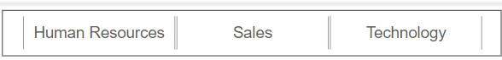Allow filtering by department (e.g., Human Resources, Sales, Technology) to view department-specific metrics and insights.
* **Visuals**:
  + 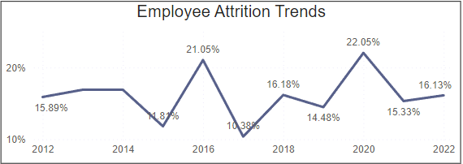**Attrition Trends Over Time**: Line chart to show monthly attrition.

* + A graph of a company

    Description automatically generated**Employee Distribution by State**: stacked column chart show number of employee by state.
  + A graph of a number of people

    Description automatically generated**Employee Count by Age**: Age distribution stacked column chart.
  + A graph with numbers and a bar

    Description automatically generated**Employee distribution by department to Job role**: stacked column chart of Employee distribution by department and breakdown to Job role

* + A screen shot of a graph

    Description automatically generated**Gender Analysis**: Pie chart of male, female, non-binary & prefer not to say employees.
  + A screenshot of a graph

    Description automatically generated**Marital Status Breakdown**: Pie chart showing percentages of single, married, and divorced employees.
  + A pie chart with text and numbers

    Description automatically generated**Travel Frequency Overview**: Show how often employees travel for work.

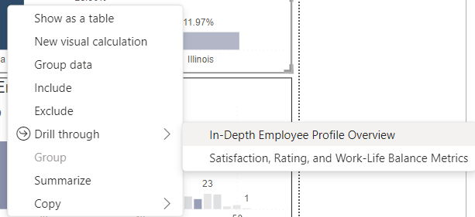Finally, it is possible to navigate to In-depth employee profile and other metrics such as work-life balance, and satisfaction and rating levels using the drill through feature.

* 1. **In Depth Employee Profile Overview – Dashboard**
* **Visuals**:
  + 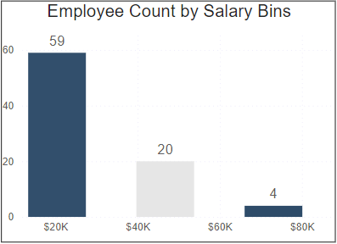**Employee Count by Salary Bins:** stacked column chart that shows how employees are categorized by their salary bin.
  + 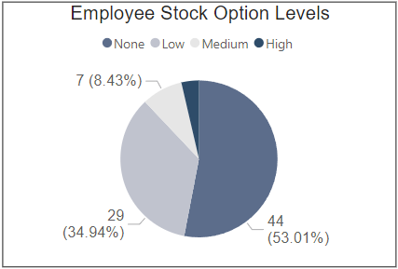**Employee Stock Option Levels:** pie chart that shows the stock option levels distribution among the employees at the company.
  + 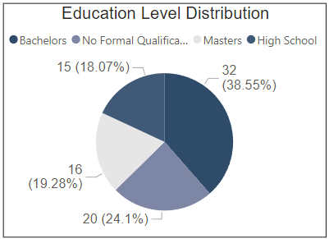**Education Level Distribution:** pie chart that shows the educational level distribution of the employees at the company.
  + 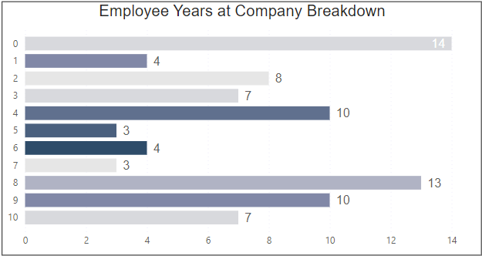**Employee Years at Company Breakdown:** stacked column chart that shows the number of employees’ years spent at the company, ex – There are 8 employees that completed their second year at the company.
  + 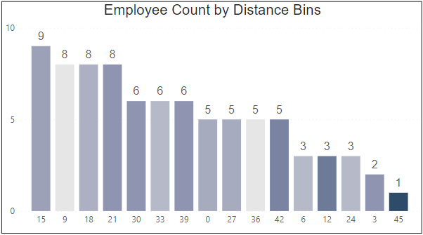**Employee Count by Distance Bins:** stacked column chart that shows how employees are categorized by their Distance from company in kilometers*(km).*
  1. **Satisfaction, Rating and Work-Life Balance Metrics – Dashboard**
* **Filters**:

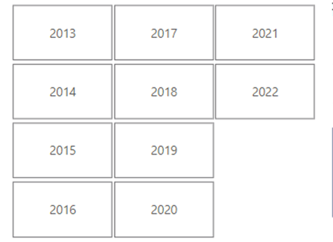Allow filtering by department (e.g., Human Resources, Sales, Technology) to view department-specific metrics and insights.

* **Visuals**:
  + A graph of a chart

    Description automatically generated with medium confidence**Overview of Manager Ratings:** stacked column chart that shows total number in each rating given by managers to their employees.
  + 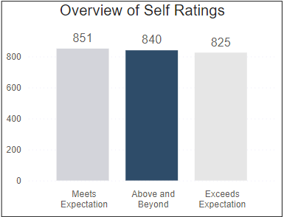**Overview of Self Ratings:** stacked column chart that shows how employees’ rate and see their performance.
  + 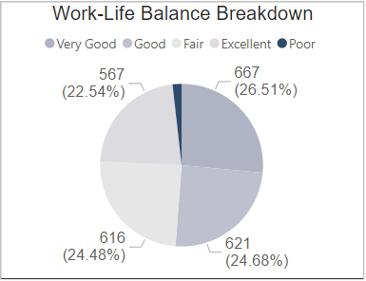**Work-Life Balance Breakdown:** pie chart that shows the rating of the work-life balance from employees’ perspective.
  + 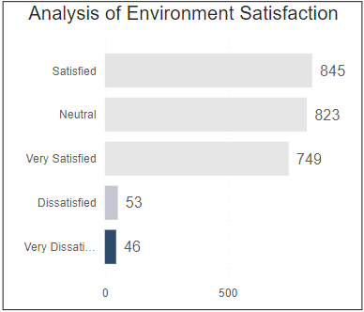**Analysis of Environment Satisfaction:** stacked column chart that shows how employees are satisfied with the work environment.
  + 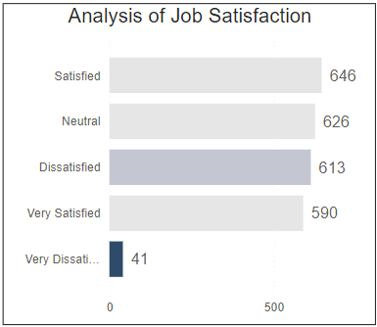**Analysis of Job Satisfaction:** stacked column chart that shows how employees are satisfied from their jobs.
  + 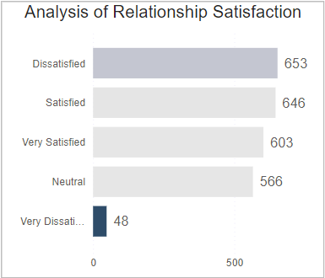**Analysis of Relationship Satisfaction:** stacked column chart that shows how employees are satisfied with the relationships at work.

1. **Conclusion**

Based on the insights from the employee attrition analysis dashboards, here are some key conclusions:

* Attrition is a significant issue: The organization is experiencing a relatively high attrition rate, particularly in certain departments and among specific employee groups.
* Multiple factors contribute to attrition: Several factors are influencing employee turnover, including low manager ratings, job dissatisfaction, workplace relationship issues, long commutes, and compensation levels.
* Targeted interventions are necessary: To effectively address attrition, the organization should implement targeted strategies to improve manager effectiveness, enhance job satisfaction, foster a positive workplace culture, address commuting challenges, and ensure fair compensation.
* Continuous monitoring and analysis: Regular monitoring and analysis of employee attrition data are crucial for identifying emerging trends and evaluating the effectiveness of implemented strategies.